**Model Architecture Report**

**1) Overview**

This model is a simple Convolutional Neural Network (CNN) built using TensorFlow/Keras for multiclass image classification of plant diseases. It processes color images of size 224x224x3 and classifies them into one of the classes found in the PlantVillage dataset.

**2) Architecture Details**

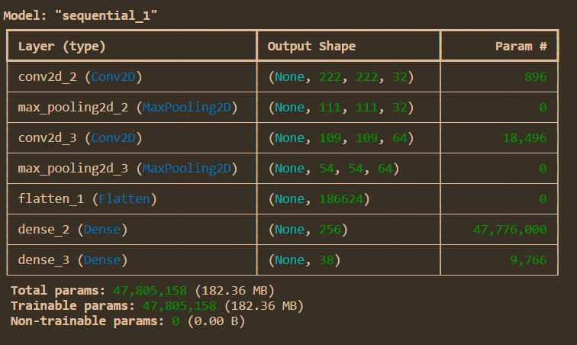

**Compilation Configuration**

* Optimizer: Adam (adaptive learning rate optimization)
* Loss Function: Categorical Crossentropy (suitable for multi-class classification with one-hot encoded labels)
* Metrics: Accuracy

**Callbacks**

Stops training if validation loss does not improve for 2 consecutive epochs, and restores the best weights.

**Summary**

Total Layers : 7

Trainable Params : ~48 million (based on Flatten size)

Model Type : Shallow CNN (2 conv layers, 1 FC layer)

Purpose : Multi-class plant disease classification